IFC’s ESG Performance Indicators — FAQ

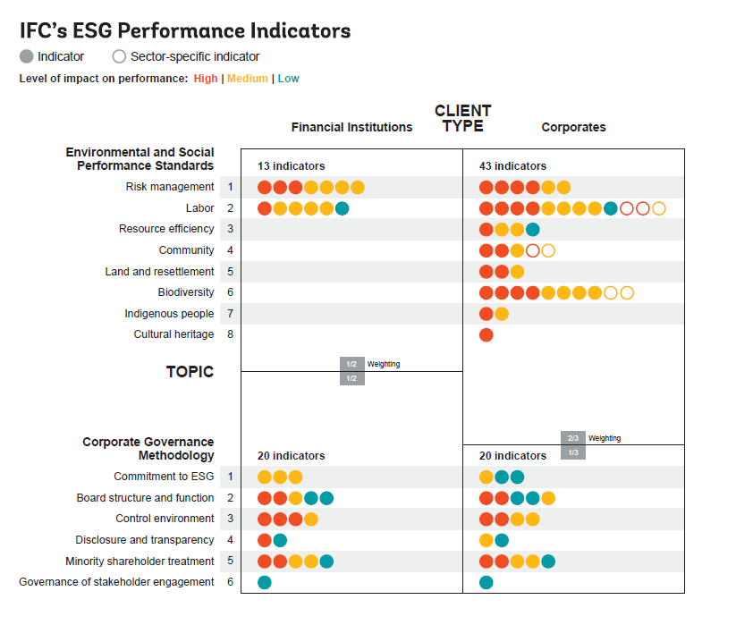

What are IFC’s ESG Performance Indicators?
IFC’s ESG Performance Indicators are a sustainability data framework aimed at providing tools and infrastructure to help reduce the ESG data reporting burden for Emerging Market capital markets issuers and enhance sustainability reporting. IFC’s ESG Performance Indicators are based on IFC’s Environmental and Social Performance Standards and Corporate Governance Methodology, which represent globally recognized ESG risk assessment and management benchmarks.
IFC’s ESG Performance Indicators focus on making IFC’s long-standing ESG expertise available for issuers to report ESG and impact performance in capital markets and are applied based on publicly available information. The ESG Performance Indicators help investors to focus on significant ESG issues.
IFC’s ESG expertise is founded on its position as the largest investor in the private sector in Emerging Markets, with a highly diversified global portfolio of debt and equity exposures in nearly 2,000 companies in 67 countries. Between 2006 and 2016, an estimated $4.5 trillion in investments across emerging markets adhered to IFC’s standards or to principles inspired by these standards.

IFC’s Environmental and Social Performance Standards and Corporate Governance Methodology cover ESG issues that are material to all EM regions and sectors and have been proven effective through testing via IFC’s investment and advisory footprint and co-investment relationships that have allowed for a critical mass of users and demonstrated results in EMs.

How are IFC’s ESG Performance Indicators applied?
As part of its capital market's strategy, IFC aims to support building robust, efficient, and transparent markets that attract and efficiently allocate capital to support sustainable private sector-led economic development in Emerging Markets. Reliable ESG data and analysis are crucial to develop investment strategies that integrate ESG issues. There is considerable variability in ESG data collected and analyzed for EM issuers, making it difficult for investors to determine the quality of ESG analysis and consider the potential materiality of this analysis to long term financial results. To address these gaps in ESG data reporting, IFC has developed a methodology drawn from its ESG standards and adjusted to the circumstances of capital markets.

IFC’s ESG Performance Indicators may be applied entirely using publicly available data. This includes primary issuer-reported data and secondary data sources. Data sources may include:
- Company websites
- Annual Reports, Sustainability reports, Integrated Annual Reports
- Information disclosed publicly to Regulators and Stock Exchanges
- News reports, NGO reports
- Second opinion provider reports
- Information on Development Financial Institutions Disclosure portals, Equator Principles website

